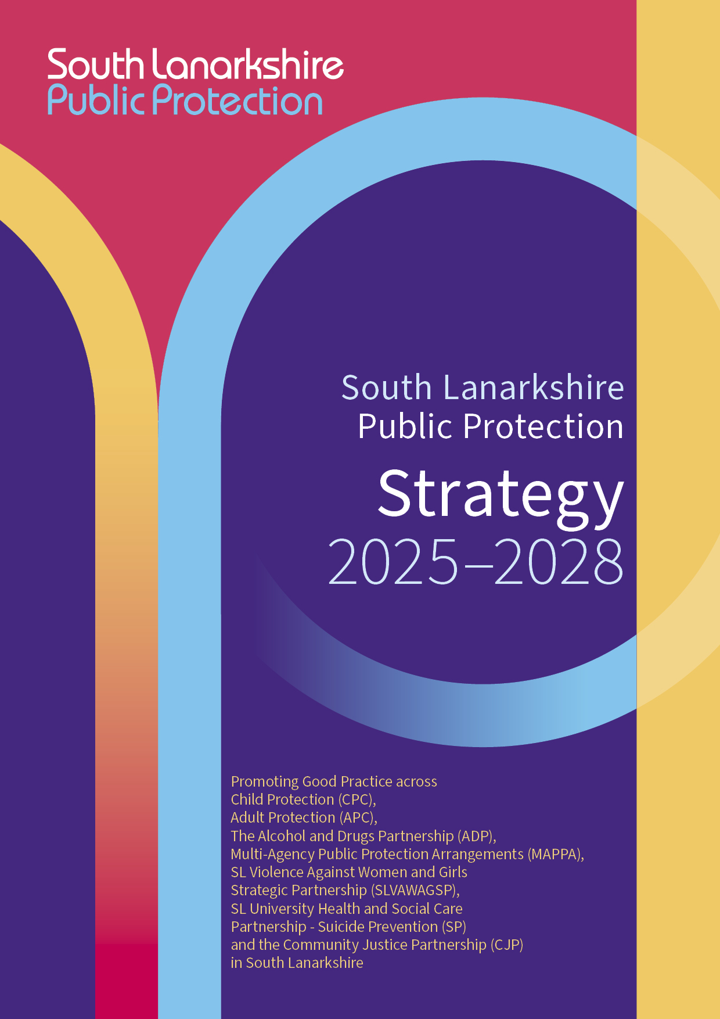

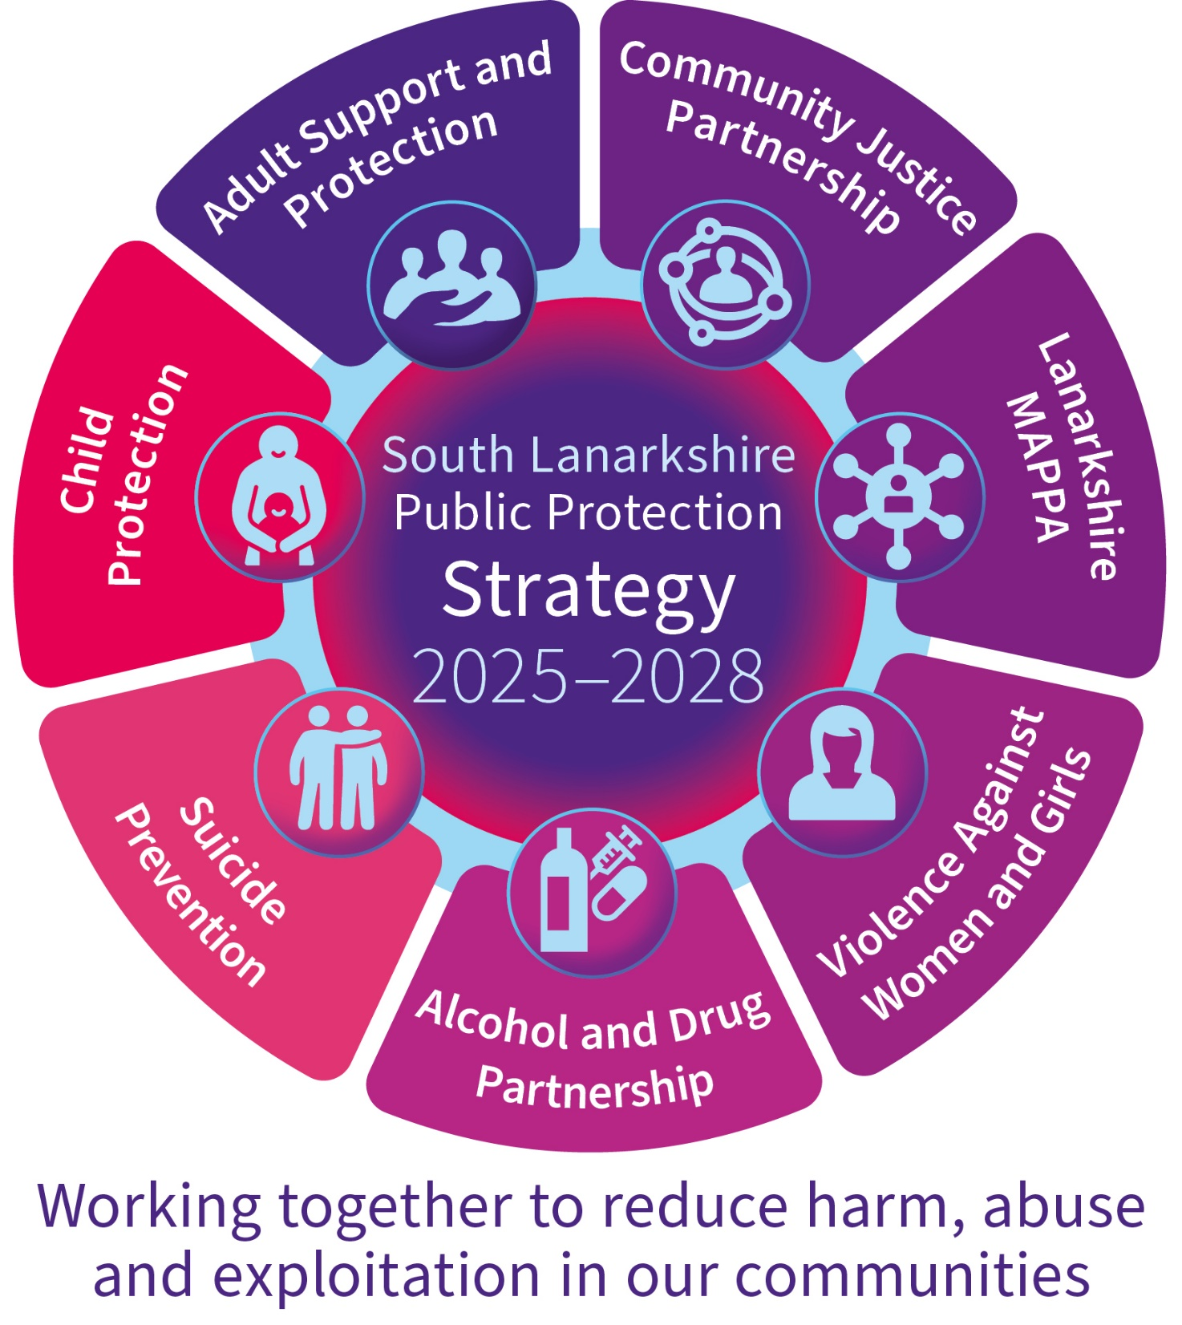

Our aim
Public protection requires agencies in South Lanarkshire to work together at both a strategic and operational level to raise awareness and understanding, and co-ordinate an effective response that provides at-risk individuals with the support needed to reduce the risk in their lives. It involves working with survivors, victims and perpetrators to reduce the risk of harm to children, adults and the public.

Our vision
To promote multi agency partnership working which reduces the risk of harm, abuse or exploitation to children, young people, adults and members of the public in our communities.

Our leadership
The South Lanarkshire Chief Officers Group (Public Protection) (Appendix 1) are responsible for ensuring that their agencies, individually and collectively, work to protect adults, children and young people as effectively as possible. Chief Officers are responsible for overseeing the commissioning of all adult and child protection services and are accountable for this work and its effectiveness. They are individually responsible for promoting adult and child protection across all areas of their individual services and agencies, thus ensuring a holistic approach to public protection in its widest context. This responsibility applies equally to the public, private and third sectors. They also have responsibility for maximising the involvement of those agencies not under their direct control.

Our outcomes
Public Protection in South Lanarkshire is dedicated to the continuous improvement of a full range of public protection services and builds on improvement by using a robust continuous process of self-evaluation based on clear and tangible priorities. This approach supports the delivery of clearly defined measures for vulnerable, or at-risk adults, children, young people and families and support the partners’ own business plans. The Chief Officers (Public Protection) have a dedicated work plan and action tracker to ensure needs are being met and actions concluded with clear evidence of sustained change.

Our team
Public Protection in South Lanarkshire is supported by a dedicated team (Appendix 2) and promotes effective partnership working between the Adult Support and Protection Committee (ASPC), the Child Protection Committee (CPC), Multi Agency Public Protection Arrangements (MAPPA), Suicide Prevention, the Alcohol and Drug Partnership (ADP), the Violence Against Women and Girls (VAWG) Partnership and the Community Justice Partnership. Action taken sits across both strategic and policy level and is reinforced through the structural arrangements of the South Lanarkshire Public Protection Chief Officer’s Group.

Work within and across Public Protection is carried out on a multi-agency basis, and it is important that each agency is clear about its own role and responsibility and understands the role of the other agencies involved. South Lanarkshire’s Public Protection Committees have a clear focus for their work and recognise the importance of the agencies represented across the partnerships working seamlessly towards clear and tangible outcomes. They work together to agree aims, objectives and outcomes in all joint activity.

The South Lanarkshire Child Protection Committee (CPC) is a multi-agency strategic group responsible for the design, development, publication, distribution, dissemination, implementation and evaluation of child protection policy and practice in South Lanarkshire. The key role of the Child Protection Committee relates to individual and collective leadership and direction for the management of child protection services across the statutory and voluntary sectors. It considers all its work in the context of GIRFEC (Getting it Right for Every Child) and wellbeing whilst working to support services reduce the risk of harm, abuse or neglect to children and young people in our community. It reports regularly to the Chief Officers Group on issues of local and National importance. For more information please visit: www.childprotectionsouthlanarkshire.org.uk The Child Protection Committee Annual Report and Business Plan can be found on the website or by emailing the Lead Officer: publicprotectionoffice@southlanarkshire.gov.uk

The South Lanarkshire Adult Support and Protection Committee (ASPC) is a multi-agency body established under the terms of the Adult Support and Protection (Scotland) Act 2007 to ensure a coordinated approach to the protection of adults at risk of harm in South Lanarkshire. The Committee’s main aim is to promote the highest standards of inter-agency practice in the protection of adults. For more information please visit: www.adultprotectionsouthlanarkshire.org.uk. The Adult Support and Protection Biennial Report can be found on the website or by emailing the Lead Officer: publicprotectionoffice@southlanarkshire.gov.uk

Multi Agency Public Protection Arrangements (MAPPA) is the framework which joins up the agencies who manage offenders. The fundamental purpose of MAPPA is public safety and the reduction of serious harm. The introduction of MAPPA across Scotland in April 2007 gave a consistent approach to the management of offenders across all local authority and police areas, providing a framework for assessing and managing the risk posed by those offenders subject to MAPPA provision. The Strategic Oversight Group (SOG) has representatives from the MAPPA responsible authorities and oversees all aspects of MAPPA in Lanarkshire. The MAPPA Annual Report can be found on the website or by emailing the Lead Officer: publicprotectionoffice@southlanarkshire.gov.uk

The South Lanarkshire Alcohol and Drug Partnership (ADP) is a dedicated multi-agency partnership that has strategic responsibility for developing local strategies for tackling, reducing and preventing harmful alcohol and drug use in the four localities of South Lanarkshire, namely Clydesdale, East Kilbride, Hamilton and Rutherglen/Cambuslang. In addition, SLADP has responsibility for the planning and commissioning of services to deliver improved local outcomes, taking into account local needs, circumstances and resources. SLADP is made up of a number of key partner agencies who have an interest in early intervention and prevention, providing treatment and intervention for people experiencing problematic alcohol and drug use.

The South Lanarkshire Community Justice Partnership (CJP) deals with situations that people can face before and after the criminal justice process of arrest, trial, and sentence. It involves the issues facing potential offenders and ex-offenders and aims to prevent crimes occurring in the first place, or recurring after a sentence has been served. The Scottish Government introduced the Community Justice (Scotland) Act 2016 and in accordance with the Act the South Lanarkshire Community Justice Partnership was established. The Scottish Government’s vision, as set out in their revised National Strategy for Community Justice 2024-2028, is reflected in the South Lanarkshire CJP’s Outcome Improvement Plan 2024-2029, which has been developed with contributions from all partner agencies. To find out more of the work being carried out by the partnership you can access the outcome improvement plan on the council’s website:
Community Justice Outcome Improvement Plan 2024-2029.

The Violence Against Women and Girls (VAWG) Partnership is the multi-agency mechanism to deliver on Equally Safe: Scotland’s strategy for preventing and eradicating violence against women and girls at a local strategic level. The Partnership aims to promote the delivery of an integrated, high-quality response to Gender-Based violence in South Lanarkshire. It is made up of key partners from the statutory and voluntary sector and is responsible for developing and implementing South Lanarkshire’s Gender-Based Violence / Violence Against Women and Girls Strategy.
For more information contact the Violence Against Women and Girls (Gender-Based Violence) worker: publicprotectionoffice@southlanarkshire.gov.uk

South Lanarkshire University Health and Social Care partnership have recently recruited a Suicide Prevention worker to enhance the focus on suicide prevention within local Public Protection arrangements. The lead will support the work of the South Lanarkshire Suicide Prevention Strategy Group comprising of membership from the Council, NHS Lanarkshire, third sector and key stakeholders representing service user and carer organisations and wider communities of interest. The lead will build upon existing work in relation to areas such as Contextual Safeguarding and the Time, Space and Compassion model. A programme of Assist multi-agency training will continue to be delivered.

A key focus of this work will be strengthening engagement with key stakeholders including statutory, private and third sector organisations and those with lived experience and linking with the Child and Adult Protection Committees to support a shared understanding of mental health and suicide.

Strong leadership and a competent and confident workforce play a critical role in child and adult protection and the protection of our communities. The National Public Protection Leadership Group provides multi-agency leadership of public protection across Scotland. The group’s aim is to bring coherence to public protection policy, as well as ensuring its interconnectivity with related activity on prevention and early intervention, as part of Scotland’s whole systems approach to improving outcomes. A national workplan has been developed to support the identification and response to harm across the six core public protection areas. Learning from this group will further strengthen our local PPCOG leadership approach.

Locally, our leaders routinely reflecting on their own leadership as they support others. It is therefore key, and all activities are reported to Chief Officers Group on a regular basis.

Appendix 1: South Lanarkshire Public Protection Team

Contact details:

Lead Officer Adult Protection
Lead Officer Child Protection
Child Protection Development Worker
Adult Protection Development Worker
Gender-Based Violence Development Worker
PublicProtectionOffice@southlanarkshire.gov.uk

MAPPA Co-ordinator
MAPPA.Lanarkshire@southlanarkshire.gov.uk

Lead Officer, South Lanarkshire Alcohol and Drug Partnership (ADP)
South Lanarkshire ADP Development Officer
Lanarkshireadp@lanarkshire.scot.nhs.uk

South Lanarkshire Community Justice Partnership
South Lanarkshire Community Justice Co-ordinator

Suicide Prevention Worker
Frances.McMahon@southlanarkshire.gov.uk

Appendix 2: South Lanarkshire Chief Officers Group (Public Protection)

Chief Executive, South Lanarkshire Council
Chief Executive, NHS Lanarkshire
Executive Director of Education Resources, South Lanarkshire Council
Head of Education (Inclusion), South Lanarkshire Council
Director of Health and Social Care, South Lanarkshire University Health and Social Care Partnership/South Lanarkshire Council
Head of Children and Justice Services/CSWO, South Lanarkshire Council
Executive Director of Nursing, NHS Lanarkshire
Nurse Director, South Lanarkshire University Health and Social Care Partnership/NHS Lanarkshire
Head of Health (Mental Health), NHS Lanarkshire
Director of Nursing, the State Hospital
Chief Superintendent, Police Scotland
Area Commander/Local Senior Officer Lanarkshire, Scottish Fire and Rescue Service
Locality Reporter Manager, Scottish Children’s Reporter’s Administration

If you need this information in another language or format, please contact us to discuss how we can best meet your needs.

Phone: 0303 123 1015
Email: equalities@southlanarkshire.gov.uk

